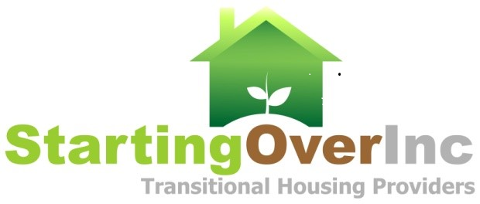

RE-IMAGINING
2021 Starting Over, Inc. Luncheon &
Barbara Barker Award Celebration
Corona Circle City Center
THURSDAY December 9, 2021 11:30 AM
Please Return Sponsorship Form No Later Than November 12, 2021. You may request to be invoiced.
PURCHASE FORM
X | SPONSORSHIP**  See the SPONSORSHIP, PROGRAM, SEATING BENEFITS & PRICING TABLE for Sponsorship Details.
 | DIAMOND (limited to 1 sponsor) |  |  |  |  |  | $10,000
 | PLATINUM (limited to 2 sponsors) |  |  |  |  |  | $7,500
 | GOLD (limited to 5 sponsors) |  |  |  |  |  | $5,000
 | SILVER |  |  |  |  |  | $2,500
 | BRONZE |  |  |  |  |  | $1,000
X | SPECIAL EDITION PROGRAM ADS**
 | FULL PAGE |  |  |  |  |  | $1,000
 | HALF PAGE |  |  |  |  |  | $500
 | QUARTER PAGE |  |  |  |  |  | $250
 | BUSINESS CARD |  |  |  |  |  | $100
SEATING**
TABLE(S) (8 Seats) |  |  | $480 |  | No. of Tables |  |  |  |  | Total $
SEAT(S) |  |  | $60 |  | No. of Seats |  |  |  |  | Total $
DONATED SEAT(S)
IMPORTANT Please email names of attendees to office@startingoverinc.org by December 1, 2021. We encourage the purchase and donation of seats for youth and seniors. Please indicate above the number of purchased seats you would like to donate.
DONATIONS
TRANSITIONAL AND PERMANENT HOUSING PROGRAM |  |  |  |  |  |  |  |  |  |  | $
Riverside All of US or NONE |  |  |  |  |  |  |  |  |  |  | $
I Am Unable to Attend But I Would Like to DONATE the Following |  |  |  |  |  |  |  |  |  |  | $
TOTAL FOR ALL ITEMS SELECTED**
Total Amount Due to Starting Over, Inc. |  |  |  |  |  |  |  |  |  |  | $
REQUIRED PURCHASER INFORMATION
Please Submit a Copy of THIS FORM with Your Check or Credit Card Information
Organization Name:
Contact Name:
Address:
City, State, Zip:
Phone: |  |  |  |  |  | Email:

CHECK PAYMENT INFORMATION |  |  | CREDIT CARD PAYMENT INFORMATION
Make Checks Payable to: | Starting Over, Inc. Fundraiser |  | Cardholder Name ___________________________  Card Number ___________________________  Billing Zip Code ___________________________
Mailing Address: | Starting Over, Inc.  1390 W 6th St. Ste 100  Corona CA 92882 |  | Expiration M/Yr ___________________________
CVS 3 Digit Code ___________________________
Signature __________________________________

We are a 501(c)(3) nonprofit, Tax Id: 90-0455003.For additional information please contact: Gwen Elzy, Starting Over, Inc Board member and Fundraising Committee Chair at 909 728 3654 or gwen.elzy17@gmail.com

